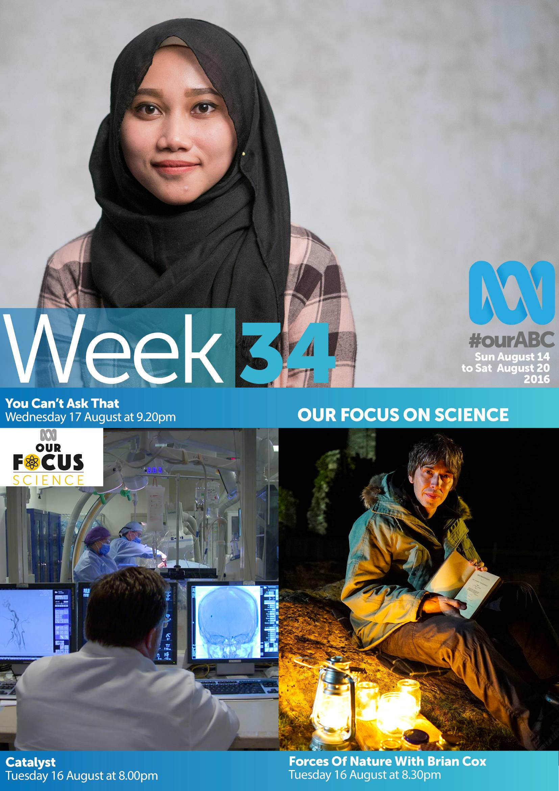
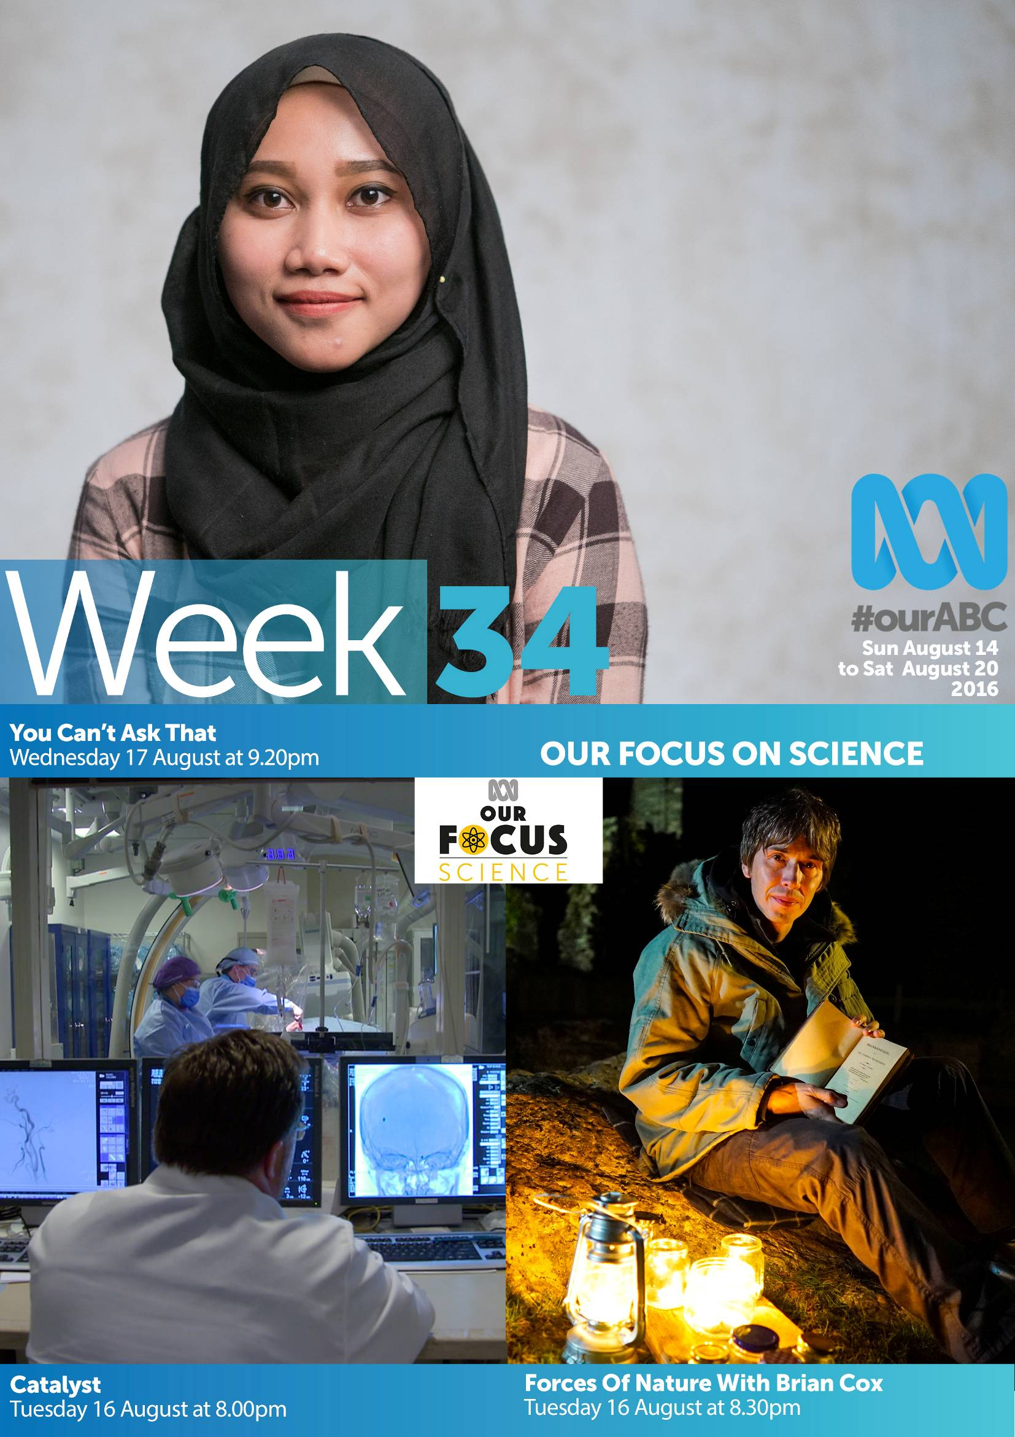
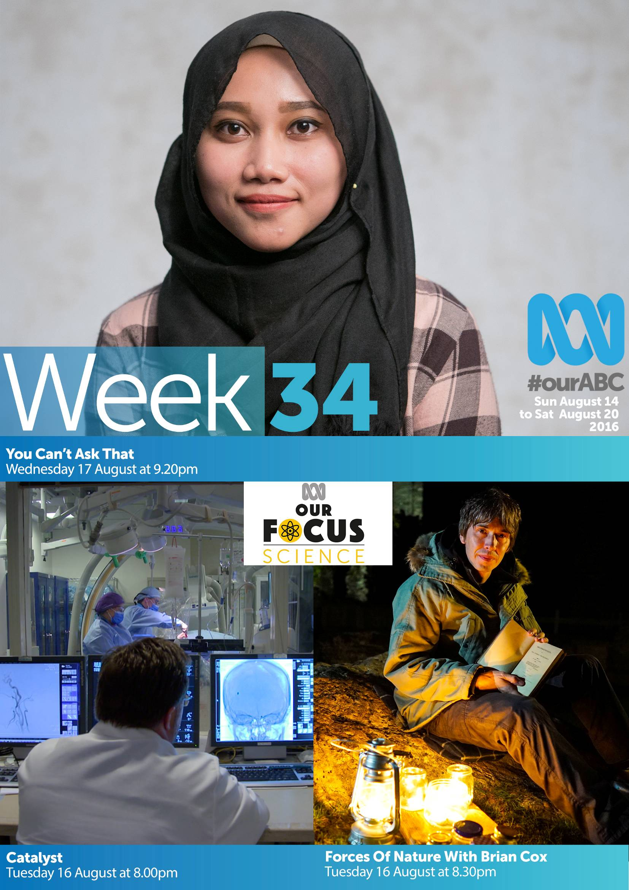
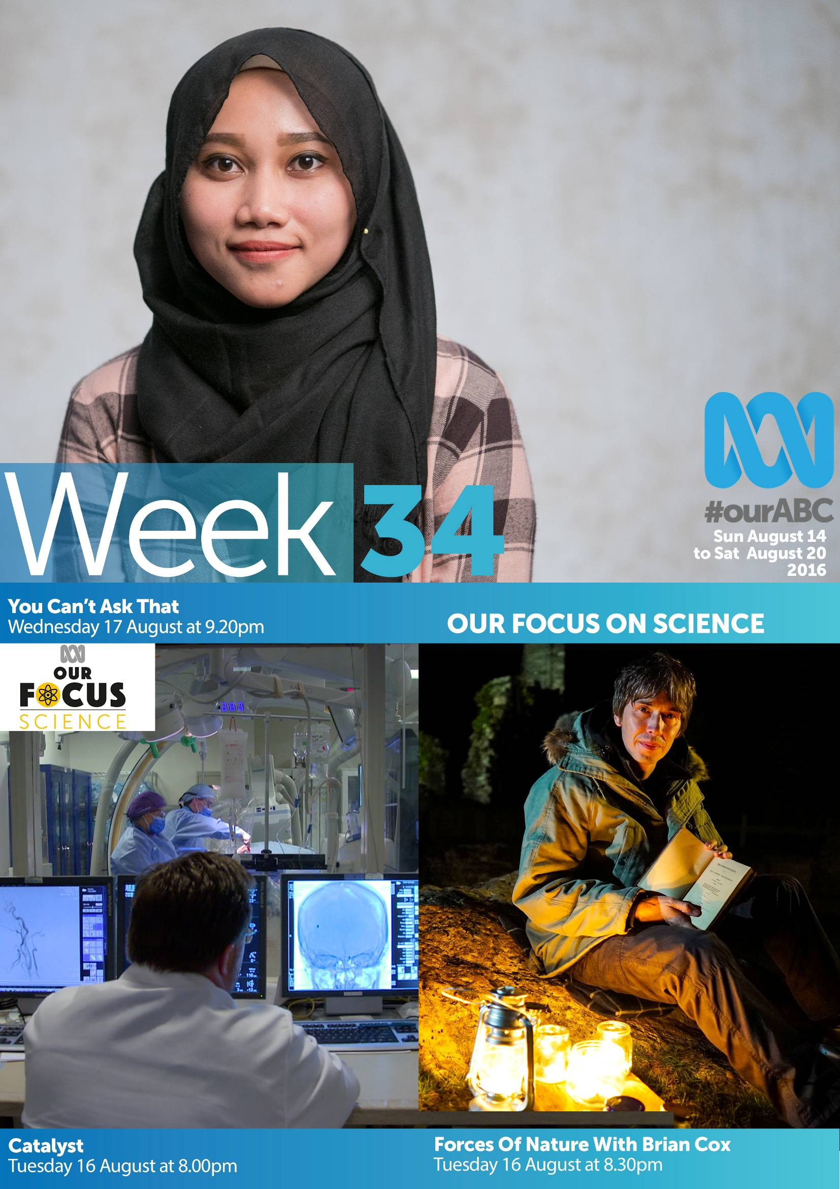
Index
Program Guide 3
Sunday, 14 August 2016 3
Monday, 15 August 2016 7
Tuesday, 16 August 2016 10
Wednesday, 17 August 2016 13
Thursday, 18 August 2016 18
Friday, 19 August 2016 23
Saturday, 20 August 2016 26
Amendments 29
Marketing Contacts 41

Program Guide

Sunday, 14 August 2016
6:00am | rage  (CC,PG)  Wall-to-wall music videos, from new releases to classics and the long-forgotten. For more information visit the rage website. #WatchingRage
7:00am | Weekend Breakfast  (CC)  Presented by Andrew Geoghegan & Miriam Corowa, covering the latest news from Australia and around the world, with in-depth analysis and interviews, as well as sport, weather and what's happening in the arts.
9:00am | Insiders  (CC)  Barrie Cassidy presents Australia's most popular political program. Insiders interview the key players, providing analysis, opinion & robust debate from the country's leading political commentators. #Insiders
10:00am | Offsiders  (CC)  Gerard Whateley is joined by a panel of sportswriters, commentators & experts to discuss & dissect the week in sport. Offsiders provides a challenging, insightful, humorous debate for those serious about sport. #Offsiders
10:30am | Australia Wide  (CC,Repeat)  Stories from the people and places that make up the Australian experience. From the city streets to the urban centres and beyond, our reporters look behind the stories that make the news. #AustraliaWide
11:00am | The World This Week  (CC,Repeat)  Beverley O'Connor presents a review of the ABC's best international news stories, with extended reports from Australia's largest network of reporters and foreign correspondents.
11:30am | Songs Of Praise: Mavis Staples  (CC,Repeat,G)  American gospel music legend Mavis Staples leads a congregation in London's Air Studios for some foot-tapping gospel songs. She talks to Aled Jones about life with her famous family the Staple Singers.
12:00pm | Landline  (CC)  Pip Courtney & a team of Landline reporters around the country bring you up to date with the issues affecting rural & regional Australia. From farming, agriculture, food, economics, innovation, climate, infrastructure & more.
1:00pm | Gardening Australia  (CC,Repeat,G)  Sophie explores a colourful Mediterranean garden; Costa discovers the wonderful world of lichen; Tino has a great DIY glass cloche-making project and Jerry meets a nature lover who has discovered a new species of mangrove.
1:30pm | The Mix  (CC,Repeat)  James Valentine presents the latest on art, TV, movies, books, games, apps, festivals, gigs, events, celebrities, theatre & all things showbiz. Get your weekly culture fix from the ABC's best arts reporters & contributors.
2:00pm | The Coroner: Napoleon's Violin  (CC,Repeat,M,Adult Themes, Violence)  Donald Sidwell, an aristocratic, elderly gentleman, races home in his vintage car to Sidwell Hall and attempts to drag his agoraphobic daughter Olivia outside as shock treatment. Later, his family discover his body.
2:45pm | Poldark  (CC,Repeat,PG)  Ross celebrates the opening of Wheal Leisure as rumours spread of a scandalous relationship between him and Demelza, and Francis and Elizabeth celebrate the birth of their new son. CAST: Aidan Turner, Eleanor Tomlinson
4:05pm | The Book Club  (CC,Repeat)Final  The Book Club wraps up its 10th series with Yuri Herrera's film noir The Transmigration of Bodies. Join Jennifer, Marieke, Jason, Virginia Gay & Margaret Pomeranz plus Paul Kelly performs a Yeats poem on stage. (Final)
4:35pm | Australian Story  (CC,Repeat)  Celebrating its 20th anniversary season, Australian Story presents unique stories that provide an insight into Australian life with all its complexities and challenges. #AustralianStory
5:10pm | David Attenborough's Conquest Of The Skies: Rivals  (CC,Repeat,G)  David continues his search for the origins of flying animals, he charts the rise of new larger creatures: extinct reptiles that flew on wings of skin & dinosaurs that sprouted feathers to become the ancestors of birds.
6:00pm | Surfing The Menu: The Next Generation: Carnarvon  (CC,G)  Dan and Hayden wander through the cyclone devasted town, through recovering beds of rocket, green papaya & black Sapote. They come across the local Tongan community who are just beginning to roast a pig on a spit.
6:30pm | Compass: The Meaning Of Life - Martin Sheen  (CC,PG)  Actor Martin Sheen talks to Irish broadcasting legend Gay Byrne about the people, events, ideas, values and beliefs that give his life meaning.
7:00pm | ABC News Sunday  (CC)
7:40pm | Grand Designs New Zealand: 45 Degree House  (CC,G)  An architect attempts to build a four-storey family home on a steep slope overlooking Wellington - and has a creative solution to protecting it against earthquakes.
8:30pm | Wallander: A Lesson In Love  (CC,M,Adult Themes, Violence)  Wallander investigates the murder of a middle-aged woman. As tensions escalate, Wallander begins to sense he is being followed, but by demons that he cannot yet identify. CAST: Kenneth Branagh
10:00pm  *Our Focus  On Science* | Redesign My Brain With Todd Sampson: Make Me Creative  (CC,Repeat,PG)  See TV personality Todd Sampson put brain training to the test in Make Me Creative, as he trains his brain to be more creative, innovative and to think more laterally, before attempting a creative art challenge.
11:00pm  *Our Focus  On Science* | Becoming Superhuman  (CC,Repeat,PG)  Biomedical engineer Dr Jordan Nguyen helps Riley, a 13-year-old kid with cerebral palsy explore new levels of independence by inventing technology that uses eye movement to power technology & even drive a car.
12:00am | Our Girl  (CC,Repeat,M,Coarse Language, Violence)  The platoon is bored in Camp Bastion, preparing to withdraw from Afghanistan. Molly finds herself at the centre of an illicit love triangle that compromises army regulations.
1:00am | rage  (MA,Rage Warning - Adult Themes, Coarse Language, Drug Use, Horror, Nudity, Sex References, Violence)  Wall-to-wall music videos, from new releases to classics and the long-forgotten. For more information go to the rage website. #WatchingRage
2:35am | Lifers  (CC,Repeat,M,Adult Themes)  The extraordinary stories of three missionaries who have devoted their lives to working in some of the most challenging and dangerous corners of the world.
3:30am | Wallander: A Lesson In Love  (CC,Repeat,M,Adult Themes, Violence)  Wallander investigates the murder of a middle-aged woman. As tensions escalate, Wallander begins to sense he is being followed, but by demons that he cannot yet identify. CAST: Kenneth Branagh
5:00am | Insiders  (CC,Repeat)  Barrie Cassidy presents Australia's most popular political program. Insiders interview the key players, providing analysis, opinion & robust debate from the country's leading political commentators. #Insiders

Monday, 15 August 2016
6:00am | ABC News Breakfast  (CC)
9:00am | ABC News Mornings  (CC)
10:00am | Landline  (CC,Repeat)
11:00am | Compass  (CC,Repeat,PG)
11:30am | Eggheads  (CC,Repeat,G)
12:00pm | ABC News At Noon  (CC)
1:00pm | Grand Designs New Zealand  (CC,Repeat,G)
2:00pm | David Attenborough's Conquest Of The Skies  (CC,Repeat,G)
2:50pm | Surfing The Menu: The Next Generation  (CC,Repeat,G)
3:20pm | The Bill  (CC,Repeat,PG)
4:10pm | Murder, She Wrote  (CC,PG)
5:00pm | ABC News: Early Edition  (CC)
5:30pm | The Drum  (CC)
6:00pm | Antiques Roadshow: Aberystwyth  (CC,Repeat,G)  Fiona Bruce and the team of experts visit Aberystwyth Arts Centre in Wales, where finds include a musical 19th century bird in a cage.
7:00pm | ABC News
7:30pm | 7.30  (CC)  The best analysis of local, national and international events from an Australian perspective. Hosted by Leigh Sales, with political commentary from 7.30 Political Editor Sabra Lane in Canberra. #abc730
8:00pm | Australian Story  (CC)  Celebrating its 20th anniversary season, Australian Story presents unique stories that provide an insight into Australian life with all its complexities and challenges. #AustralianStory
8:30pm | Four Corners  (CC)  Australia's premier television current affairs program, hosted by Sarah Ferguson. Four Corners has been part of the national story since 1961, exposing scandals, triggering inquiries, firing debate and confronting taboos.
9:20pm | Media Watch  (CC,PG)  Australia's leading forum for media analysis and comment, presented by one of Australia's most respected journalists Paul Barry. #MediaWatch
9:35pm | Q&A  (CC)  Hosted by Tony Jones, Q&A puts punters, pollies and pundits together in the studio to thrash out the hot issues of the week. It's about democracy in action - the audience gets to ask the questions. #QandA
10:40pm | Lateline  (CC,Repeat)  Hosted by Emma Alberici, Lateline provides original journalism and investigations, quality analysis and insightful interviews, combined with a fresh approach to telling important stories. #Lateline
11:10pm | The Business  (CC,Repeat)  Ticky Fullerton and Elysse Morgan examine the day's business and finance news and delve into the trends and forces driving local and global markets.
11:30pm | Golf: PGA TOUR Highlights: Silvis, Illinois  (CC)  See the world's best golfers in action with Highlights from the latest event on the PGA TOUR.
12:25am | Bluestone 42  (CC,Repeat,M,Coarse Language, Sexual References)  A British comedy drama series following the lives of a bomb disposal detachment serving in Afghanistan. CAST: Oliver Chris, Gary Carr
12:55am | The Mix  (CC,Repeat)  James Valentine presents the latest on art, TV, movies, books, games, apps, festivals, gigs, events, celebrities, theatre & all things showbiz. Get your weekly culture fix from the ABC's best arts reporters & contributors.
1:25am | rage  (MA,Rage Warning - Adult Themes, Coarse Language, Drug Use, Horror, Nudity, Sex References, Violence)  Wall-to-wall music videos, from new releases to classics and the long-forgotten. For more information go to the rage website. #WatchingRage
3:50am | Doc Martin  (CC,Repeat,PG)  Louisa and Martin are arguing about everything, from the schooling for their son to what they will eat for supper. Then Martin books a christening without telling Louisa. CAST: Martin Clunes
4:35am | Eggheads: Crazy Golfers  (CC,Repeat,G)  A team of challengers takes on seven of the greatest quiz show champions for a chance of winning a cash prize. Every time the Eggheads win, that prize increases. Hosted by Jeremy Vine.
5:05am | The Bill:  (CC,Repeat,PG)  Brownlow nervously awaits the visit of the inspector with the future of Sun Hill at stake and Burnside makes a deal with a convict.

Tuesday, 16 August 2016
6:00am | ABC News Breakfast  (CC)
9:00am | ABC News Mornings  (CC)
10:00am | Four Corners  (CC,Repeat)
10:45am | Media Watch  (CC,Repeat,PG)
11:00am | Outback ER  (CC,Repeat,PG,This program depicts emergency medical situations.)
11:30am | Eggheads  (CC,Repeat,G)
12:00pm | ABC News At Noon  (CC)
1:00pm | Doc Martin  (CC,Repeat,PG)
1:50pm | Antiques Roadshow  (CC,Repeat,G)
2:50pm | The Cook And The Chef  (CC,Repeat,G)
3:20pm | The Bill  (CC,Repeat,PG)
4:10pm | Murder, She Wrote  (CC,PG)
5:00pm | ABC News: Early Edition  (CC)
5:30pm | The Drum  (CC)
6:00pm | Antiques Roadshow: Remembrance Special  (CC,Repeat,G)  In this special edition, Fiona Bruce and Roadshow specialists draw together a powerful group of previously unheard stories of wartime and sacrifice at the National Memorial Arboretum in Staffordshire.
7:00pm | ABC News
7:30pm | 7.30  (CC)  The best analysis of local, national and international events from an Australian perspective. Hosted by Leigh Sales, with political commentary from 7.30 Political Editor Sabra Lane in Canberra. #abc730
8:00pm  *Our Focus  On Science* | Catalyst  (CC,PG)  Catalyst looks at the game-changing new Australian device that aims to help the paralysed walk again. Plus virtual reality takes scientists and patients on a unique interactive journey inside the human body.
8:30pm  *Our Focus  On Science* | Forces Of Nature With Brian Cox: The Moth and The Flame  (CC,PG,This program includes depictions of traditional practices that may concern some viewers)  Professor Brian Cox shows how Earth’s basic ingredients, like the pure sulphur mined in the heart of a deadly volcano in Indonesia, have become the building blocks of life.
9:30pm | Foreign Correspondent  (CC)  Australia's leading international affairs program featuring fascinating, in-depth stories from the ABC's unrivalled network of foreign correspondents. #ForeignCorrespondent
10:00pm | Keith Haring Uncovered  (CC,PG)  In 1984 American artist Keith Haring visited Australia and created a mural in Collingwood, Melbourne. This is the story of the mural which is now one of only 31 known murals by Haring that are still in existence worldwide.
10:30pm | Lateline  (CC,Repeat)  Hosted by Emma Alberici, Lateline provides original journalism and investigations, quality analysis and insightful interviews, combined with a fresh approach to telling important stories. #Lateline
11:00pm | The Business  (CC,Repeat)  Ticky Fullerton and Elysse Morgan examine the day's business and finance news and delve into the trends and forces driving local and global markets.
11:20pm | Q&A  (CC,Repeat)  Hosted by Tony Jones, Q&A puts punters, pollies and pundits together in the studio to thrash out the hot issues of the week. It's about democracy in action - the audience gets to ask the questions. #QandA
12:25am | Conquest Of Space: Sci-Fi & Art  (CC,Repeat,PG)  Andrew Frost explores how a very specific genre of popular culture - sci-fi - with its storylines and themes has come to influence contemporary Australian art.
12:55am | Anatomy: Nerve  (CC,Repeat,MA,Sex Scenes)  Australian photographer, Paul Knight, has an ambitious project - Proposition. He has built his artistic career on pushing the boundaries of sexual representation. Now he wants to find two strangers who will have sex on film.
1:25am | rage  (MA,Rage Warning - Adult Themes, Coarse Language, Drug Use, Horror, Nudity, Sex References, Violence)  Wall-to-wall music videos, from new releases to classics and the long-forgotten. For more information go to the rage website. #WatchingRage
3:35am | Forces Of Nature With Brian Cox: The Moth and The Flame  (CC,Repeat,PG,This program includes depictions of traditional practices that may concern some viewers)  Professor Brian Cox shows how Earth’s basic ingredients, like the pure sulphur mined in the heart of a deadly volcano in Indonesia, have become the building blocks of life.
4:35am | Eggheads: On The Beat  (CC,Repeat,G)  A team of challengers takes on seven of the greatest quiz show champions for a chance of winning a cash prize. Every time the Eggheads win, that prize increases. Hosted by Jeremy Vine.
5:05am | The Bill:  (CC,Repeat,PG)  An old enemy turns up asking for Burnside’s help and Quinnan's ways as a police officer get him into trouble with Monroe.

Wednesday, 17 August 2016
6:00am | ABC News Breakfast  (CC)
9:00am | ABC News Mornings  (CC)
10:00am | Q&A  (CC,Repeat)
11:15am | One Plus One  (CC,Repeat,G)
11:30am | Eggheads  (CC,Repeat,G)
12:00pm | ABC News At Noon  (CC)
12:30pm | National Press Club Address  (CC)
1:30pm | Jennifer Byrne Presents 7 Deadly Sins  (CC,Repeat,G)
2:00pm | Antiques Roadshow  (CC,Repeat,G)
3:00pm | The Cook And The Chef  (CC,Repeat,G)
3:20pm | The Bill  (CC,Repeat,PG)
4:10pm | Murder, She Wrote  (CC,PG)
5:00pm | ABC News: Early Edition  (CC)
5:30pm | The Drum  (CC)
6:00pm | Antiques Roadshow: Seaton Delaval 1  (CC,Repeat,G)  Fiona Bruce and the team of experts travel to Northumberland to the recently reopened Seaton Delaval Hall. Family treasures under scrutiny include a hand-made wooden model that could be the world's first toy train.
7:00pm | ABC News
7:30pm | 7.30  (CC)  The best analysis of local, national and international events from an Australian perspective. Hosted by Leigh Sales, with political commentary from 7.30 Political Editor Sabra Lane in Canberra. #abc730
8:00pm | QI: Lethal  (CC,Repeat,PG,This program contains content that may concern some viewers.)Final  Stephen Fry looks at the quite interesting side of all things lethal, with a deadly and dangerous panel of Bill Bailey, Sandi Toksvig, Jason Manford and Alan Davies. (Final)
8:30pm | Gruen  (CC)  Gruen is back to find out why we buy what we buy. Wil, Russel, Todd & a team of new & familiar faces will deconstruct the advertising landscape. #Gruen
9:10pm | The Katering Show: It Gets Feta  (CC,M,Coarse Language)  McLennan has found a cure for McCartney's debilitating lactose intolerance. To celebrate, McLennan makes a cheese feast stuffed with dairy loaded puns and delusion; afflictions that, unfortunately, have no known cure.
9:20pm | You Can't Ask That: Muslim  (CC,PG)  Muslims answer the questions Australians wanted to ask but were too embarrassed or afraid to ever ask in person.
9:35pm | Soul Mates II  (CC,MA,Coarse Language)  Bondi Hipsters Dom & Adrian shoot a short film; Mum takes measures to ensure Roger's spot in the rugby team, Seti discovers Amram's mother & wife are two different people and the Cavemen explore comedy. #SoulMatesTV
10:10pm | Would I Lie To You?: Jack Dee, Romesh Ranganathan, Gaby Roslin, Tinchy Stryder  (CC,PG)  Rob Brydon hosts the award-winning comedy panel show with David Mitchell and Lee Mack as the lightning-quick team captains. Tonight's guests are Jack Dee, Romesh Ranganathan, Gaby Roslin and Tinchy Stryder.
10:40pm | Lateline  (CC,Repeat)  Hosted by Tony Jones, Lateline provides original journalism and investigations, quality analysis and insightful interviews, combined with a fresh approach to telling important stories. #Lateline
11:10pm | The Business  (CC,Repeat)  Ticky Fullerton and Elysse Morgan examine the day's business and finance news and delve into the trends and forces driving local and global markets.
11:30pm | Four Corners  (CC,Repeat)  Australia's premier television current affairs program, hosted by Sarah Ferguson. Four Corners has been part of the national story since 1961, exposing scandals, triggering inquiries, firing debate and confronting taboos.
12:15am | Media Watch  (CC,Repeat,PG)  Australia's leading forum for media analysis and comment, presented by one of Australia's most respected journalists Paul Barry. #MediaWatch
12:30am | The Moaning Of Life: Death  (CC,Repeat,M,Adult Themes, Coarse Language, Sexual References)Final  Karl Pilkington has never had to think much about death. So how do other cultures deal with it? Starting in Ghana he shops for a 'crazy coffin' before attending his first ever funeral and helping the undertaker. (Final)
1:20am | QI: Lethal  (CC,Repeat,PG,This program contains content that may concern some viewers.)  Stephen Fry looks at the quite interesting side of all things lethal, with a deadly and dangerous panel of Bill Bailey, Sandi Toksvig, Jason Manford and Alan Davies.
1:50am | Would I Lie To You?: Jack Dee, Romesh Ranganathan, Gaby Roslin, Tinchy Stryder  (CC,Repeat,PG)  Rob Brydon hosts the award-winning comedy panel show with David Mitchell and Lee Mack as the lightning-quick team captains. Tonight's guests are Jack Dee, Romesh Ranganathan, Gaby Roslin and Tinchy Stryder.
2:20am | Agony Aunts: Break Ups  (CC,Repeat,M,Sexual References)  Our Agony Aunts guide you through the tumult of relationship break up.
2:50am | Accused: Tina's Story  (CC,Repeat,MA,Adult Themes, Coarse Language, Violence)Final  A prison officer is the victim of a series of betrayals and cover-ups. CAST: Anna Maxwell Martin, Ewen Bremner (Final)
3:50am | Doc Martin  (CC,Repeat,PG)  Bert Large's restaurant is in financial trouble, and son Al blames it on his dad, it's not helped by the fact that loan sharks are after them; Dr Ellingham wants to leave the village and go back to being a surgeon. CAST Martin Clunes
4:35am | Eggheads: The Badgers  (CC,Repeat,G)  A team of challengers takes on seven of the greatest quiz show champions for a chance of winning a cash prize. Every time the Eggheads win, that prize increases. Hosted by Jeremy Vine.
5:05am | The Bill:  (CC,Repeat,PG)  The closure of a local nightclub pits Burnside against his closest friends and his boss. Loxton and Peters attend court to see the sentence of a local gangster.
Other States:
Northern Territory
4:35am | The Bill:  (CC,Repeat,PG)  The closure of a local nightclub pits Burnside against his closest friends and his boss. Loxton and Peters attend court to see the sentence of a local gangster
5.30am | ABC News Breakfast  (CC)
Western Australia State
4:00am | ABC News Breakfast  (CC)
South Australia State
4:00am | The Bill:  (CC,Repeat,PG)  The closure of a local nightclub pits Burnside against his closest friends and his boss. Loxton and Peters attend court to see the sentence of a local gangster
5.30am | ABC News Breakfast  (CC)

Thursday, 18 August 2016
6:00am | ABC News Breakfast  (CC)
9:00am | ABC News Mornings  (CC)
10:00am | Australia Remembers: Long Tan Memorial Service  (CC)  On Vietnam Veterans' Day, a special Commemorative Service from the Australian War Memorial in Canberra to mark 50 Years since the Battle of Long Tan, the most costly battle in terms of casualties in the Vietnam War.
11:00am | Who's Been Sleeping In My House?  (CC,Repeat,G)
11:30am | Eggheads  (CC,Repeat,G)
12:00pm | ABC News At Noon  (CC)
1:00pm | Doc Martin  (CC,Repeat,PG)
1:50pm | Antiques Roadshow  (CC,Repeat,G)
2:50pm | The Cook And The Chef  (CC,Repeat,G)
3:20pm | The Bill  (CC,Repeat,PG)
4:10pm | Murder, She Wrote  (CC,PG)
5:00pm | ABC News: Early Edition  (CC)
5:30pm | The Drum  (CC)
6:00pm | Antiques Roadshow: Hartland Abbey 1  (CC,Repeat,G)  Fiona Bruce and the team head to Hartland Abbey in Devon and amongst the items catching their eyes are the World War Two notebooks of a young plane spotter who may have witnessed Glenn Miller's last flight.
6:55pm | Clarke And Dawe  (CC,G)  Join satirical duo John Clarke and Bryan Dawe for their irreverent take on the week's news headlines.
7:00pm | ABC News  (CC)
7:30pm | 7.30  (CC)  The best analysis of local, national and international events from an Australian perspective. Hosted by Leigh Sales, with political commentary from 7.30 Political Editor Sabra Lane in Canberra. #abc730
8:00pm | The Checkout  (CC,PG)  Over three and a half seasons, The Checkout's revolutionary new wonder diet of clinically proven* consumer infotainment has been hailed by critics as 'marginally better than A Current Affair'. #TheCheckout
8:30pm | New Blood  (CC,M,Violence)  Rash & Sands investigate a series of high-end burglaries, while Stefan & the SFO investigate fraudster Daniel Lorca. They raid the office & home of his lawyer, John Malik. CAST: Mark Strepan, Ben Tavossoli
9:30pm | Jonathan Creek: The Sinner & The Sandman  (CC,Repeat,M,Sexual References)  As Jonathan and Polly struggle to settle into rural life, they find their apparently serene country village is riddled with all manner of strange and disturbing undercurrents. CAST: Alan Davies
10:30pm | Lateline  (CC,Repeat)  Hosted by Tony Jones, Lateline provides original journalism and investigations, quality analysis and insightful interviews, combined with a fresh approach to telling important stories. #Lateline
11:05pm | The Business  (CC,Repeat)  Ticky Fullerton and Elysse Morgan examine the day's business and finance news and delve into the trends and forces driving local and global markets.
11:20pm  *Our Focus  On Science* | Enigma Man: A Stone Age Mystery  (CC,Repeat,M,Adult Themes, Sex Scenes)  Australian and Chinese scientists uncover strange, ancient human remains from a remote cave in South West China and are confronted with a shocking possibility. Could these bones represent a new human species?
12:20am | The Wrong Mans: Running Mans  (CC,Repeat,M,Coarse Language, Violence)Final  Sam and Phil are now on the run, on the edge and on each other's nerves. CAST: James Corden, Mat Baynton (Final)
12:55am  In National  Science Week | National Press Club Address: Dr Michael Gannon  (CC,Repeat)  President of the Australian Medical Association Dr Michael Gannon addresses the National Press Club. #npc
1:55am | Golf: PGA TOUR Highlights: Silvis, Illinois  (CC,Repeat)  See the world's best golfers in action with Highlights from the latest event on the PGA TOUR.
2:50am | New Blood  (CC,Repeat,M,Violence)  Rash & Sands investigate a series of high-end burglaries, while Stefan & the SFO investigate fraudster Daniel Lorca. They raid the office & home of his lawyer, John Malik. CAST: Mark Strepan, Ben Tavossoli
3:50am | Doc Martin  (CC,Repeat,PG)Final  Mrs Tishell's long standing crush on Dr Martin Ellingham takes a dramatic turn in this final episode. Fuelled by a cocktail of drugs she boards a bus, taking baby James Henry with her. CAST: Martin Clunes
4:35am | Eggheads: Glebe Glimmers  (CC,Repeat,G)  A team of challengers takes on seven of the greatest quiz show champions for a chance of winning a cash prize. Every time the Eggheads win, that prize increases. Hosted by Jeremy Vine.
5:05am | The Bill  (CC,Repeat,PG)  Cryer finds himself up against a solicitor who is the key to stopping his career from ending forever and Tony investigates a case of domestic violence.
Other States:

Northern Territory
6:00am | ABC News Breakfast  (CC)
8:30am | ABC News Mornings  (CC)
9:30am | Australia Remembers: Long Tan Memorial Service  (CC)
10:30am | Foreign Correspondent  (CC,Repeat)

South Australia State
6:00am | ABC News Breakfast  (CC)
8:30am | ABC News Mornings  (CC)
9:30am | Australia Remembers: Long Tan Memorial Service  (CC)
10:30am | Foreign Correspondent  (CC,Repeat)

Western Australia State
6:00am | ABC News Breakfast  (CC)
7:00am | ABC News Mornings  (CC)
8:00am | Australia Remembers: Long Tan Memorial Service  (CC)
9:00am | ABC News Mornings  (CC)
10:00am | Australian Story  (CC,Repeat)
10:30am | Foreign Correspondent  (CC,Repeat)

Friday, 19 August 2016
6:00am | ABC News Breakfast  (CC)
9:00am | ABC News Mornings  (CC)
10:00am | One Plus One  (CC)
10:30am | Catalyst  (CC,Repeat,PG)
11:00am | From The Heart  (CC,Repeat,G)
11:30am | Eggheads  (CC,Repeat,G)
12:00pm | ABC News At Noon  (CC)
1:00pm | Doc Martin  (CC,Repeat,PG)Final
1:50pm | Antiques Roadshow  (CC,Repeat,G)
2:50pm | The Cook And The Chef  (CC,Repeat,G)
3:20pm | The Bill  (CC,Repeat,PG)
4:10pm | Murder, She Wrote  (CC,PG)
5:00pm | ABC News: Early Edition  (CC)
5:30pm | The Drum  (CC)
6:00pm | Antiques Roadshow: Hartland Abbey 2  (CC,Repeat,G)Final  A day in North Devon draws thousands to Hartland Abbey as the experts search for more treasure. Discoveries brought to the cameras include a quilt believed to have been made from ball gowns worn in the Royal Household.
7:00pm | ABC News
7:30pm | 7.30  (CC)  The best analysis of local, national and international events from an Australian perspective. Hosted by Leigh Sales, with political commentary from 7.30 Political Editor Sabra Lane in Canberra. #abc730
8:00pm | Tony Robinson's Time Walks: Alice Springs  (CC,PG)Final  Tony's last walk finishes at one of Central Australia's most spectacular natural landmarks. Alice Springs is a tiny speck in a vast, red, dry interior...but it's a fertile oasis of historical highlights. (Final)
8:30pm | New Tricks: Life Expectancy  (CC,Repeat,M,Adult Themes)  In the penultimate episode of the final season, a blood-stained bust is uncovered during construction work in a cemetery. The evidence points to the murder of an alternative-medicine practitioner seven years earlier.
9:30pm | Exile  (CC,Repeat,M,Adult Themes, Coarse Language, Sex Scenes, Violence)  As Sam's behaviour becomes more erratic, Tom steps up his investigation into Metzler. But his actions may put them both in danger. CAST: John Simm, Olivia Colman & Jim Broadbent
10:30pm | Lateline  (CC,Repeat)  Hosted by Emma Alberici, Lateline provides original journalism and investigations, quality analysis and insightful interviews, combined with a fresh approach to telling important stories. #Lateline
11:05pm | The Business  (CC,Repeat)  Ticky Fullerton and Elysse Morgan examine the day's business and finance news and delve into the trends and forces driving local and global markets.
11:20pm | Adam Hills: The Last Leg: David Mitchell  (CC,Repeat,M,Coarse Language, Sexual References)  David Mitchell joins Adam Hills, Josh Widdicombe and Alex Brooker to tackle the big talking points of the week including Australia's entry into the Eurovision Song Contest. Plus they answer your #IsItOK questions.
12:00am | rage  (MA,Rage Warning - Adult Themes, Coarse Language, Drug Use, Horror, Nudity, Sex References, Violence)  Wall-to-wall music videos, from new releases to classics and the long-forgotten. For more information visit the rage website. #WatchingRage
5:00am | rage  (CC,PG)  Wall-to-wall music videos, from new releases to classics and the long-forgotten. For more information visit the rage website. #WatchingRage

Saturday, 20 August 2016
6:00am | rage  (CC,PG)  Join us as we count down 20 of the most popular videos from the ARIA Singles Chart plus special chart predictions and appearances from some of the most popular acts of today. #WatchingRage
10:30am | rage Guest Programmer  (CC,PG)  Wall-to-wall music videos, from new releases to classics and the long-forgotten. Also featuring special guests who program their favourites. For more information go to the rage website. #WatchingRage
11:30am | The Checkout  (CC,Repeat,PG)  Over three and a half seasons, The Checkout's revolutionary new wonder diet of clinically proven* consumer infotainment has been hailed by critics as 'marginally better than A Current Affair'. #TheCheckout
12:00pm  As part of ABC’s Focus On Science Week | Reptilian Battleground  (CC,Repeat,PG)  Track the journeys of saltwater crocodiles and ocean-going turtles, as they converge on an extraordinary natural arena.
1:00pm | New Tricks: Life Expectancy  (CC,Repeat,PG)  In the penultimate episode of the final season, a blood-stained bust is uncovered during construction work in a cemetery. The evidence points to the murder of an alternative-medicine practitioner seven years earlier.
2:00pm | Antiques Roadshow: Hartland Abbey 2  (CC,Repeat,G)Final  A day in North Devon draws thousands to Hartland Abbey as the experts search for more treasure. Discoveries brought to the cameras include a quilt believed to have been made from ball gowns worn in the Royal Household.
3:00pm | Tony Robinson's Time Walks: Alice Springs  (CC,Repeat,PG)Final  Tony's last walk finishes at one of Central Australia's most spectacular natural landmarks. Alice Springs is a tiny speck in a vast, red, dry interior...but it's a fertile oasis of historical highlights. (Final)
3:30pm | Inside The Commons: Lifting The Lid  (CC,Repeat,G)  We follow two new female MPs, Charlotte Leslie and Sarah Champion, as they learn the ways of the House, and we meet the people who keep the Commons running including the Clerk of the House.
4:30pm | Landline  (CC,Repeat)  Pip Courtney & a team of Landline reporters around the country bring you up to date with the issues affecting rural & regional Australia. From farming, agriculture, food, economics, innovation, climate, infrastructure & more.
5:00pm | Midsomer Murders: The Night Of The Stag  (CC,Repeat,PG)  When a missing tax inspector turns up dead in a vat of cider, Barnaby and Jones must hunt for a 'giant' killer within a Midsomer village steeped in bizarre local traditions. CAST: Neil Dudgeon, Jason Hughes
6:30pm | Gardening Australia  (CC,G)  Tino maintains his lawn; John meets a South African garden designer; Costa prunes camellias; Josh visits a large Perth hills garden; and Sophie profiles aloes.
7:00pm | ABC News  (CC)
7:30pm | The Coroner: The Deep Freeze  (CC,PG)  When ice cream factory manager Rose finds owner Robert frozen to death in one of his freezers, Jane & Davey are called in to investigate. Rose is adamant that Robert wouldn't have killed himself as he was about to retire. CAST: Claire Goose
8:20pm | Inspector George Gently: Gently Among Friends  (CC,Repeat,M,Adult Themes, Violence)  Amid the UK's wildcat rubbish bin strikes, there's tension among friends and disagreement over what's happening, and one of them ends up dead. Inspector Gently and DS Bacchus investigate. CAST: Martin Shaw, Lee Ingleby.
9:50pm | Poldark  (CC,Repeat,PG)  News of the marriage between Ross and Demelza shocks Trenwith, while Charles' amusement at the union bringing on a fatal heart attack. CAST: Aidan Turner, Eleanor Tomlinson.
10:50pm | Cilla  (CC,Repeat,PG)  With Cilla & Bobby reunited, Cilla's confidence returns and she is once again dazzling crowds with her amazing voice. The re-emergence of Brian Epstein propels her career to new heights. But can it last? CAST: Sheridan Smith
11:40pm | rage Guest Programmer  (MA,Rage Warning - Adult Themes, Coarse Language, Drug Use, Horror, Nudity, Sex References, Violence)  Wall-to-wall music videos, from new releases to classics and the long-forgotten. Also featuring special guests who program their favourites. For more information go to the rage website. #WatchingRage
5:00am | rage  (PG)  Wall-to-wall music videos, from new releases to classics and the long-forgotten. For more information visit the rage website. #WatchingRage

Amendments

Wednesday, July 20
Amend Synopsis Text:
05:30PM The Drum
Tonight on The Drum: Julia Baird is hosting with former leader of the Australian Greens Bob Brown,
columnist at the Daily Life and SBS Ruby Hamad and recently retired Liberal MP Philip Ruddock.
#TheDrum

Amend Classification, Warning:
08:30PM Shaun Micallef's MAD AS HELL
(M), Coarse Language

Amend Start time:
09:40PM Adam Hills: The Last Leg
Previous Start Time 09:35PM

Insert Classification, Warning:
09:40PM Adam Hills: The Last Leg
(M), Adult Themes, Coarse Language, Sexual References

Amend Start time:
11:10PM Four Corners
Previous Start Time 11:05PM

Amend Start time:
11:55PM Media Watch
Previous Start Time 11:50PM

Insert Classification, Warning:
02:55AM Adam Hills: The Last Leg
(M), Adult Themes, Coarse Language, Sexual References

Thursday, July 21
Amend Start time:
10:30PM Lateline
Previous Start Time 10:25PM

Friday, July 22
Amend Synopsis Text:
06:00AM ABC News Breakfast
Start your day with the very latest news, incisive analysis and intelligent debate. Hosted by Michael
Rowland and Kumi Taguchi, sport with Paul Kennedy, finance with Del Irani and weather with Vanessa
O'Hanlon.

Amend Episode Title, Synopsis Text:
10:00AM One Plus One
Justin Lin
As a boy growing up in a migrant family in the US, Justin Lin watched Star Trek avidly for 10 years.
He's now one of Hollywood's hottest directors & his latest film Star Trek Beyond celebrates
50 Years of the franchise.

Amend Start time:
10:55AM Croc College
Previous Start Time 11:00AM

Amend Start time:
11:25AM Eggheads
Previous Start Time 11:30AM

Saturday, July 23
Amend Start time:
10:05PM Arthur And George
Previous Start Time 10:10PM

Amend Synopsis Text:
11:25PM Jennifer Byrne Presents Great War Stories
Jennifer Byrne invites a panel including Merrick Watts, Peter Fitzsimons & Dr Christina Spittel
to bring in their favourite books about WWI to discuss & recommend to the audience on #GreatWarStories

Amend Synopsis Text:
12:00AM Australia Remembers: Pozieres Centenary Commemoration
The Pozieres Service at the 1st AIF Memorial commemorates the Battle of Pozieres, marking 100 years
since the first major Australian battles of WWI on the Western Front.

Amend Synopsis Text:
01:15AM rage Guest Programmer: Deafheaven
Aptly named band Deafheaven will bring a mix of the brutal & the sublime. Hailing from San Francisco,
Deafheaven's sound is a mix of influences: combining elements of black metal, post metal & shoegaze.

Sunday, July 24
Amend Synopsis Text:
09:00AM Insiders
Guest host Fran Kelly interviews the Attorney-General George Brandis. On the panel: Fleur Anderson,
David Marr & Malcolm Farr plus Talking Pictures with Strewth columnist James Jeffrey. #Insiders

Amend Synopsis Text:
10:00AM Offsiders
Gerard Whateley leads an Offsiders discussion on sport through the eyes of our national coaches:
Socceroos coach Ange Postecoglou, Wallabies coach Michael Cheika and Diamonds coach Lisa Alexander.
#Offsiders

Amend Synopsis Text:
10:30AM Australia Wide
Unravelling medical mysteries. The dark history of an NT leper colony. Reintroducing native wildlife
in Canberra. A grassroots exercise group for mums. #AustraliaWide.

Insert Warning:
10:30AM Australia Wide
Aboriginal and Torres Strait Islander viewers are advised that the following program does contain images and voices of people who have died

Amend Synopsis Text:
12:00PM Landline
A ground-breaking environmental project using dingoes to eradicate feral goats from an island in north
Queensland; and Chinese tourists flock to a sleepy Mallee town to witness the magic of LakeTyrell

Amend Synopsis Text:
01:30PM The Mix
The Mix is in Cairns for the Indigenous Art Fair, 100s of Kate Bush fans stage the ultimate tribute,
and colouring in - just a fad? Plus, 5 Indigenous artists you should know, & the race against
time for Aust's film archives.

Amend Synopsis Text:
06:00PM Surfing The Menu: The Next Generation
Dan & Hayden visit Shark Bay to see the dolphins & try unsuccessfully to catch crabs. They visit
a Salt farm, 1,000 year-old Stromatalites. They find wild Samfire and meet local indigenous
man character Capes.

Amend Classification, Warning:
10:25PM Shaun Micallef's MAD AS HELL
(M), Coarse language

Amend Synopsis Text:
03:20AM Movie: The Spanish Main
In the Caribbean the fiancée of the Spanish viceroy is kidnapped by a pirate who determines
to tame her before marrying her. CAST: Paul Henreid, Maureen O'Hara, Walter Slezak DIR: Frank Borzage
(1945)

Amend Synopsis Text:
05:00AM Insiders
Guest host Fran Kelly interviews the Attorney-General George Brandis. On the panel: Fleur Anderson,
David Marr & Malcolm Farr plus Talking Pictures with Strewth columnist James Jeffrey. #Insiders

Sunday, July 24 QLD Only
Amend Synopsis Text:
07:00PM ABC News Sunday
Local, National and International News hosted by Louisa Rebgetz. ABC News Sunday features an extended
Special Report, investigating and exploring in depth the issues that affect Queensland.

Monday, July 25
Amend Synopsis Text:
06:00AM ABC News Breakfast
Start your day with the very latest news, incisive analysis and intelligent debate. Hosted by Michael
Rowland and Kumi Taguchi, sport with Paul Kennedy, finance with Del Irani and weather with Vanessa
O'Hanlon.

Amend Synopsis Text:
10:00AM Landline
A ground-breaking environmental project using dingoes to eradicate feral goats from an island in north
Queensland; and Chinese tourists flock to a sleepy Mallee town to witness the magic of LakeTyrell.

Amend Synopsis Text:
02:50PM Surfing The Menu: The Next Generation
Dan & Hayden visit Shark Bay to see the dolphins & try unsuccessfully to catch crabs. They visit
a Salt farm, 1,000 year-old Stromatalites. They find wild Samfire and meet local indigenous
man character Capes.

Amend Synopsis Text:
05:30PM The Drum
Julia Baird is joined by Senior Counsel Kate Eastman, CEO of the Victorian Aboriginal Child Care
Agency Muriel Bamblett plus Rebecca Weisser who's a contributor to The Spectator Australia & Quadrant.
#TheDrum

Amend Start time:
05:55PM Antiques Roadshow
Previous Start Time 06:00PM

Amend Episode Title, Synopsis Text:
08:00PM Australian Story
Gone Girl
Gone Girl: Two young people fall in love and marry, but are torn apart when one of them is taken
into immigration detention. Supporters are determined to see the decision reversed. #AustralianStory

Amend Synopsis Text:
08:30PM Four Corners
Australia's Shame: The brutalisation of children behind bars. This confronting investigation
by Caro Meldrum-Hanna will send shockwaves around Australia. #4Corners

Insert Episode Title:
08:30PM Four Corners
Australia's Shame
Amend Start time:
09:25PM Media Watch
Previous Start Time 09:20PM

Amend Start time:
09:40PM Q&A
Previous Start Time 09:35PM

Amend Synopsis Text:
09:35PM Q&A
Joining guest host Virginia Trioli: Assistant Minister for Industry Craig Laundy; Labor MP Ed Husic;
President of the Human Rights Commission Gillian Triggs; Cape York Institute's Shireen Morris & Rev
Peter Kurti. #QandA

Amend Episode Title:
09:35PM Q&A
Craig Laundy, Ed Husic, Gillian Triggs, Shireen Morris, Rev Peter Kurti

Amend Episode Title, Synopsis Text:
09:35PM Q&A
Craig Laundy, Ed Husic, Shireen Morris, Reverend Peter Kurti
Joining guest host Virginia Trioli on the panel: Assistant Minister for Industry, Innovation
and Science Craig Laundy; Labor MP Ed Husic; Cape York Institute's Shireen Morris; and Reverend
Peter Kurti. #QandA

Amend Start time:
10:45PM Lateline
Previous Start Time 10:40PM

Amend Start time:
11:15PM The Business
Previous Start Time 11:10PM

Amend Start time, Synopsis Text:
12:55AM The Mix
Previous Start Time 01:00AM
The Mix is in Cairns for the Indigenous Art Fair; Kate Bush fans stage the ultimate tribute;
Colouring in - just a fad? Plus 5 Indigenous artists you should know & the race against time for Australia's
film archives.

Amend Start time:
01:00AM The Mix
Previous Start Time 12:55AM

Amend Start time:
01:30AM rage
Previous Start Time 01:25AM

Tuesday, July 26
Amend Synopsis Text:
06:00AM ABC News Breakfast
Start your day with the very latest news, incisive analysis and intelligent debate. Hosted by Michael
Rowland and Kumi Taguchi, sport with Paul Kennedy, finance with Del Irani and weather with Vanessa
O'Hanlon.

Amend Start time:
09:55AM Four Corners
Previous Start Time 10:00AM

Amend Synopsis Text:
10:00AM Four Corners
Australia's Shame: The brutalisation of children behind bars. This confronting investigation
by Caro Meldrum-Hanna will send shockwaves around Australia. #4Corners

Insert Episode Title:
10:00AM Four Corners
Australia's Shame

Amend Start time:
10:50AM Media Watch
Previous Start Time 10:45AM

Amend Synopsis Text:
05:30PM The Drum
Analysis of the day's news in an engaging & entertaining way. Host Julia Baird leads a panel of journalists,
political & social commentators in a lively, thought-provoking discussion. #TheDrum

Amend Classification, Warning:
08:00PM Catalyst
(G), This program includes scenes of childbirth, and nudity.
Amend Episode Title:
08:00PM Catalyst
Gut Reaction (Part 1)

Amend Synopsis Text:
08:00PM Catalyst
Could our food be making us sick - very sick? In the first of a two-part special, Dr Graham Phillips
reveals research about the interplay between food and the bacteria deep within our guts. #ABCcatalyst

Amend Synopsis Text:
08:00PM Catalyst
This two part Catalyst special investigates whether food could actually be our medicine. #ABCcatalyst

Amend Synopsis Text:
08:30PM Martin Clunes: Man And Beast
Martin Clunes looks at how pet ownership in Japan is scaling new heights. For many years there have
been more dogs & cats than children. Now more than 24 million cats & dogs share the pavements
of Japan. (Final)

Insert Classification:
09:50PM The Book Club
(G)

Amend Synopsis Text:
11:10PM Q&A
Joining guest host Virginia Trioli: Assistant Minister for Industry Craig Laundy; Labor MP Ed Husic;
President of the Human Rights Commission Gillian Triggs; Cape York Institute's Shireen Morris & Rev
Peter Kurti. #QandA

Amend Episode Title:
11:10PM Q&A
Craig Laundy, Ed Husic, Gillian Triggs, Shireen Morris, Rev Peter Kurti

Amend Episode Title, Synopsis Text:
11:10PM Q&A
Craig Laundy, Ed Husic, Shireen Morris, Reverend Peter Kurti
Joining guest host Virginia Trioli on the panel: Assistant Minister for Industry, Innovation
and Science Craig Laundy; Labor MP Ed Husic; Cape York Institute's Shireen Morris; and Reverend
Peter Kurti. #QandA

Amend Start time:
11:10PM Q&A
Previous Start Time 11:05PM

Tuesday, July 26 SA Only
Amend Start time:
11:05PM Q&A
Previous Start Time 11:10PM

Tuesday, July 26 TAS Only
Amend Start time:
11:05PM Q&A
Previous Start Time 11:10PM

Tuesday, July 26 VIC Only
Amend Start time:
11:05PM Q&A
Previous Start Time 11:10PM

Tuesday, July 26 WA Only
Amend Start time:
11:05PM Q&A
Previous Start Time 11:10PM

Wednesday, July 27
Amend Synopsis Text:
06:00AM ABC News Breakfast
Start your day with the very latest news, incisive analysis and intelligent debate. Hosted by Michael
Rowland and Kumi Taguchi, sport with Paul Kennedy, finance with Del Irani and weather with Vanessa
O'Hanlon.

Amend Synopsis Text:
10:00AM Q&A
Joining guest host Virginia Trioli: Assistant Minister for Industry Craig Laundy; Labor MP Ed Husic;
President of the Human Rights Commission Gillian Triggs; Cape York Institute's Shireen Morris & Rev
Peter Kurti. #QandA

Amend Episode Title:
10:00AM Q&A
Craig Laundy, Ed Husic, Gillian Triggs, Shireen Morris, Rev Peter Kurti

Amend Episode Title, Synopsis Text:
10:00AM Q&A
Craig Laundy, Ed Husic, Shireen Morris, Reverend Peter Kurti
Joining guest host Virginia Trioli on the panel: Assistant Minister for Industry, Innovation
and Science Craig Laundy; Labor MP Ed Husic; Cape York Institute's Shireen Morris; and Reverend
Peter Kurti. #QandA

Insert Episode Title:
11:05PM Four Corners
Australia's Shame

Amend Synopsis Text:
01:30PM Martin Clunes: Man And Beast
Martin Clunes looks at how pet ownership in Japan is scaling new heights. For many years there have
been more dogs & cats than children. Now more than 24 million cats & dogs share the pavements
of Japan. (Final)

Amend Synopsis Text:
05:30PM The Drum
Analysis of the day's news in an engaging & entertaining way. Host Julia Baird leads a panel of journalists,
political & social commentators in a lively, thought-provoking discussion. #TheDrum

Amend Synopsis Text:
08:30PM Shaun Micallef's MAD AS HELL
Trapped underground, three miners keep their spirits up by playing songs to each other on harps.
In a twist ending, it turns out the miners have been dead all along & they're actually trapped
underground in heaven. (Final)

Amend Synopsis Text:
09:35PM Adam Hills: The Last Leg
Adam Hills, Alex Brooker and Josh Widdicombe are joined by US actor & playwright Jesse Eisenberg
& star of TV's Big Bang Theory Kunal Nayyar to examine the biggest and most entertaining
news stories. (Final)

Amend Start time:
10:15PM Lateline
Previous Start Time 10:20PM

Amend Synopsis Text:
11:05PM Four Corners
Australia's Shame: The brutalisation of children behind bars. This confronting investigation
by Caro Meldrum-Hanna will send shockwaves around Australia. #4Corners

Thursday, July 28
Amend Synopsis Text:
06:00AM ABC News Breakfast
Start your day with the very latest news, incisive analysis and intelligent debate. Hosted by Michael
Rowland and Kumi Taguchi, sport with Paul Kennedy, finance with Del Irani and weather with Vanessa
O'Hanlon.

Amend Episode Title, Synopsis Text:
10:00AM Australian Story
Gone Girl
Gone Girl: Two young people fall in love and marry, but are torn apart when one of them is taken
into immigration detention. Supporters are determined to see the decision reversed. #AustralianStory

Amend Synopsis Text:
05:30PM The Drum
Analysis of the day's news in an engaging & entertaining way. Host Julia Baird leads a panel of journalists,
political & social commentators in a lively, thought-provoking discussion. #TheDrum

Amend Synopsis Text:
08:00PM The Checkout
The Checkout returns, continuing to take a no-holds-barred, irreverent and entertaining approach

Friday, July 29
Amend Synopsis Text:
06:00AM ABC News Breakfast
Start your day with the very latest news, incisive analysis and intelligent debate. Hosted by Michael
Rowland and Kumi Taguchi, sport with Paul Kennedy, finance with Del Irani and weather with Vanessa
O'Hanlon.

Amend Classification, Warning:
10:30AM Catalyst
(G), This program includes scenes of childbirth, and nudity.

Amend Synopsis Text:
10:30AM Catalyst
Could our food be making us sick - very sick? In the first of a two-part special, Dr Graham Phillips
reveals research about the interplay between food and the bacteria deep within our guts. #ABCcatalyst

Amend Synopsis Text:
10:30AM Catalyst
This two part Catalyst special investigates whether food could actually be our medicine. #ABCcatalyst

Amend Synopsis Text:
05:30PM The Drum
Analysis of the day's news in an engaging & entertaining way. Host Julia Baird leads a panel of journalists,
political & social commentators in a lively, thought-provoking discussion. #TheDrum

Amend Start time:
05:55PM Antiques Roadshow
Previous Start Time 06:00PM

Saturday, July 30
Amend Synopsis Text:
06:30PM Gardening Australia
Jane visits an expansive garden in Victoria, Costa shows us an easy technique for creating compost,Tino
shows us how to select the best seedlings & Angus checks out a council's way of dealing with potentially
hazardous trees.

Sunday, July 31
Amend Synopsis Text:
01:00PM Gardening Australia
Jane visits an expansive garden in Victoria, Costa shows us an easy technique for creating compost,Tino
shows us how to select the best seedlings & Angus checks out a council's way of dealing with potentially
hazardous trees.

Insert Classification:
03:45PM The Book Club
(G)

Amend Episode Title, Synopsis Text:
04:20PM Australian Story
Gone Girl
Gone Girl: Two young people fall in love and marry, but are torn apart when one of them is taken
into immigration detention. Supporters are determined to see the decision reversed. #AustralianStory

Amend Synopsis Text:
06:00PM Surfing The Menu: The Next Generation
Dan and Hayden surf with Alex Ramerez. David Ross invites them to the Ningaloo Reef to snorkel
and see fish, turtles & manta rays. They try for some mud crabs & go prawning from a trawler.

Amend Synopsis Text:
06:30PM Compass
With Olympic fever in the air, Moral Compass debates the ethics & values of the games. With past
results tainted by suspicion of cheating can we trust anything we see in Rio? Why do we idolise
those devoted to elite sport?

Amend Episode Title, Synopsis Text:
06:30PM Compass
The Moral Compass: What Price Glory?
In a Moral Compass special What Price Glory? Geraldine Doogue is joined by a panel of guests to discuss
the religious and ethical aspects of modern sport.

Amend Synopsis Text:
10:30PM Shaun Micallef's MAD AS HELL
Trapped underground, three miners keep their spirits up by playing songs to each other on harps.
In a twist ending, it turns out the miners have been dead all along & they're actually trapped
underground in heaven. (Final)

Sunday, July 31 QLD Only
Amend Synopsis Text:
07:00PM ABC News Sunday
Local, National and International News hosted by Louisa Rebgetz. ABC News Sunday features an extended
Special Report, investigating and exploring in depth the issues that affect Queensland.

Monday, August 01
Amend Synopsis Text:
11:00AM Compass
With Olympic fever in the air, Moral Compass debates the ethics & values of the games. With past
results tainted by suspicion of cheating can we trust anything we see in Rio? Why do we idolise
those devoted to elite sport?

Amend Synopsis Text:
02:55PM Surfing The Menu: The Next Generation
Dan and Hayden surf with Alex Ramerez. David Ross invites them to the Ningaloo Reef to snorkel
and see fish, turtles & manta rays. They try for some mud crabs & go prawning from a trawler.

Amend Episode Title, Synopsis Text:
08:00PM Australian Story
The Two Of Us
A heart-warming story of friendship between legendary jazz musician Don Burrows and the star he mentored,
James Morrison. Now with Don Burrows about to turn 88, the roles have reversed. #AustralianStory

Tuesday, August 02
Amend Episode Title, Synopsis Text:
08:00PM Catalyst
Gut Reaction (Part 2)
The final part of a Catalyst investigation into whether food could actually be our medicine.
A healthy diet could be even more important than previously thought because food affects the bacteria
deep inside our guts.

Amend Synopsis Text:
08:00PM Catalyst
The final part of the investigation into whether food could actually be our medicine. #ABCcatalyst

Wednesday, August 03
Amend Synopsis Text:
08:30PM Gruen
Gruen is back to find out why we buy what we buy. Why do the ads on the side of our internet
browser want us to buy more? Wil, Russel, Todd & a team of new & familiar faces will deconstruct
the advertising landscape. #Gruen

Thursday, August 04
Amend Episode Title, Synopsis Text:
10:00AM Australian Story
The Two Of Us
A heart-warming story of friendship between legendary jazz musician Don Burrows and the star he mentored,
James Morrison. Now with Don Burrows about to turn 88, the roles have reversed. #AustralianStory

Friday, August 05
Amend Synopsis Text:
10:30AM Catalyst
The final part of the investigation into whether food could actually be our medicine. #ABCcatalyst

Saturday, August 06
Amend Synopsis Text:
06:30PM Gardening Australia
Costa visits an old bowling club that has transformed into a community hub, Jane makes kokedama,
John explains when to water indoor plants in winter & Josh drops in on a couple to check out their
secluded private garden.

Sunday, August 07
Amend Episode Title, Synopsis Text:
04:35PM Australian Story
The Two Of Us
A heart-warming story of friendship between legendary jazz musician Don Burrows and the star he mentored,
James Morrison. Now with Don Burrows about to turn 88, the roles have reversed. #AustralianStory

Amend Synopsis Text:
08:30PM Wallander
The award-winning series starring Kenneth Branagh returns for three final thrilling stories filmed
in South Africa, Sweden & Denmark. While attending a conference, Wallander is drawn into a case of
a missing Swedish national.

Sunday, August 07 QLD Only
Amend Synopsis Text:
07:00PM ABC News Sunday
Local, National and International News hosted by Louisa Rebgetz. ABC News Sunday features an extended
Special Report, investigating and exploring in depth the issues that affect Queensland.

Tuesday, August 09
Amend Synopsis Text:
10:00PM The Book Club
The Book Club wraps up its 10th series with Yuri Herrera's Mexican film noir The Transmigration
of Bodies. Join Jennifer, Marieke, Jason, Virginia Gay & Margaret Pomeranz. (Final)

Wednesday, August 10
Amend Synopsis Text:
08:30PM Gruen
Wil, Russel, Todd & industry experts tackle the biggest advertising event in the world: The Olympics.
Which brands will win marketing gold and who will come dead last? Plus two agencies Pitch to sell
Tasmania to China. #Gruen

Amend Synopsis Text:
09:35PM Soul Mates II
The Bondi Hipsters rid Bondi of buff Brazilians, the Kiwi Assassins infiltrate a school to investigate
its rugby prowess; Seti tests his relationship with slave Amram; & the Cavemen discover the power
of trading. #SoulMatesTV

